**CCP2**

Accompagner la personne dans les actes

essentielS de la vie quotidienne

**Nom, Prénom du stagiaire :**



|  |
| --- |
| **APPRÉCIATION DU FORMATEUR :** |
| * _ _ _ _ _ _ _ _ _ _ _ _ _ _ _ _ _ _ _ _ _ _ _ _ _ _ _ _ _ _ _ _ _ _ _ _ _ _ _ _ _ _ _ _ _ _ _ _ _ _ _ _ _ _ _ _ _ _ _ _ _ * _ _ _ _ _ _ _ _ _ _ _ _ _ _ _ _ _ _ _ _ _ _ _ _ _ _ _ _ _ _ _ _ _ _ _ _ _ _ _ _ _ _ _ _ _ _ _ _ _ _ _ _ _ _ _ _ _ _ _ _ _ * _ _ _ _ _ _ _ _ _ _ _ _ _ _ _ _ _ _ _ _ _ _ _ _ _ _ _ _ _ _ _ _ _ _ _ _ _ _ _ _ _ _ _ _ _ _ _ _ _ _ _ _ _ _ _ _ _ _ _ _ _ * _ _ _ _ _ _ _ _ _ _ _ _ _ _ _ _ _ _ _ _ _ _ _ _ _ _ _ _ _ _ _ _ _ _ _ _ _ _ _ _ _ _ _ _ _ _ _ _ _ _ _ _ _ _ _ _ _ _ _ _ _ * _ _ _ _ _ _ _ _ _ _ _ _ _ _ _ _ _ _ _ _ _ _ _ _ _ _ _ _ _ _ _ _ _ _ _ _ _ _ _ _ _ _ _ _ _ _ _ _ _ _ _ _ _ _ _ _ _ _ _ _ _ * _ _ _ _ _ _ _ _ _ _ _ _ _ _ _ _ _ _ _ _ _ _ _ _ _ _ _ _ _ _ _ _ _ _ _ _ _ _ _ _ _ _ _ _ _ _ _ _ _ _ _ _ _ _ _ _ _ _ _ _ _ |

**Quelles sont les principales causes de la perte d’autonomie chez la personne aidée ?**

* _ _ _ _ _ _ _ _ _ _ _ _ _ _ _ _ _ _ _ _ _ _ _ _ _ _ _ _ _ _ _ _ _ _ _ _ _ _ _ _ _ _ _ _ _ _ _ _ _ _ _ _ _ _ _ _ _ _ _
* _ _ _ _ _ _ _ _ _ _ _ _ _ _ _ _ _ _ _ _ _ _ _ _ _ _ _ _ _ _ _ _ _ _ _ _ _ _ _ _ _ _ _ _ _ _ _ _ _ _ _ _ _ _ _ _ _ _ _
* _ _ _ _ _ _ _ _ _ _ _ _ _ _ _ _ _ _ _ _ _ _ _ _ _ _ _ _ _ _ _ _ _ _ _ _ _ _ _ _ _ _ _ _ _ _ _ _ _ _ _ _ _ _ _ _ _ _ _
* _ _ _ _ _ _ _ _ _ _ _ _ _ _ _ _ _ _ _ _ _ _ _ _ _ _ _ _ _ _ _ _ _ _ _ _ _ _ _ _ _ _ _ _ _ _ _ _ _ _ _ _ _ _ _ _ _ _ _
* _ _ _ _ _ _ _ _ _ _ _ _ _ _ _ _ _ _ _ _ _ _ _ _ _ _ _ _ _ _ _ _ _ _ _ _ _ _ _ _ _ _ _ _ _ _ _ _ _ _ _ _ _ _ _ _ _ _ _
* _ _ _ _ _ _ _ _ _ _ _ _ _ _ _ _ _ _ _ _ _ _ _ _ _ _ _ _ _ _ _ _ _ _ _ _ _ _ _ _ _ _ _ _ _ _ _ _ _ _ _ _ _ _ _ _ _ _ _

**Quel est votre rôle principal auprès de la personne aidée ?**

* _ _ _ _ _ _ _ _ _ _ _ _ _ _ _ _ _ _ _ _ _ _ _ _ _ _ _ _ _ _ _ _ _ _ _ _ _ _ _ _ _ _ _ _ _ _ _ _ _ _ _ _ _ _ _ _ _ _ _
* _ _ _ _ _ _ _ _ _ _ _ _ _ _ _ _ _ _ _ _ _ _ _ _ _ _ _ _ _ _ _ _ _ _ _ _ _ _ _ _ _ _ _ _ _ _ _ _ _ _ _ _ _ _ _ _ _ _ _
* _ _ _ _ _ _ _ _ _ _ _ _ _ _ _ _ _ _ _ _ _ _ _ _ _ _ _ _ _ _ _ _ _ _ _ _ _ _ _ _ _ _ _ _ _ _ _ _ _ _ _ _ _ _ _ _ _ _ _
* _ _ _ _ _ _ _ _ _ _ _ _ _ _ _ _ _ _ _ _ _ _ _ _ _ _ _ _ _ _ _ _ _ _ _ _ _ _ _ _ _ _ _ _ _ _ _ _ _ _ _ _ _ _ _ _ _ _ _
* _ _ _ _ _ _ _ _ _ _ _ _ _ _ _ _ _ _ _ _ _ _ _ _ _ _ _ _ _ _ _ _ _ _ _ _ _ _ _ _ _ _ _ _ _ _ _ _ _ _ _ _ _ _ _ _ _ _ _
* _ _ _ _ _ _ _ _ _ _ _ _ _ _ _ _ _ _ _ _ _ _ _ _ _ _ _ _ _ _ _ _ _ _ _ _ _ _ _ _ _ _ _ _ _ _ _ _ _ _ _ _ _ _ _ _ _ _ _

**Qu’allez-vous observer chez la personne lors de votre première intervention ?**

* _ _ _ _ _ _ _ _ _ _ _ _ _ _ _ _ _ _ _ _ _ _ _ _ _ _ _ _ _ _ _ _ _ _ _ _ _ _ _ _ _ _ _ _ _ _ _ _ _ _ _ _ _ _ _ _ _ _ _
* _ _ _ _ _ _ _ _ _ _ _ _ _ _ _ _ _ _ _ _ _ _ _ _ _ _ _ _ _ _ _ _ _ _ _ _ _ _ _ _ _ _ _ _ _ _ _ _ _ _ _ _ _ _ _ _ _ _ _
* _ _ _ _ _ _ _ _ _ _ _ _ _ _ _ _ _ _ _ _ _ _ _ _ _ _ _ _ _ _ _ _ _ _ _ _ _ _ _ _ _ _ _ _ _ _ _ _ _ _ _ _ _ _ _ _ _ _ _
* _ _ _ _ _ _ _ _ _ _ _ _ _ _ _ _ _ _ _ _ _ _ _ _ _ _ _ _ _ _ _ _ _ _ _ _ _ _ _ _ _ _ _ _ _ _ _ _ _ _ _ _ _ _ _ _ _ _ _
* _ _ _ _ _ _ _ _ _ _ _ _ _ _ _ _ _ _ _ _ _ _ _ _ _ _ _ _ _ _ _ _ _ _ _ _ _ _ _ _ _ _ _ _ _ _ _ _ _ _ _ _ _ _ _ _ _ _ _
* _ _ _ _ _ _ _ _ _ _ _ _ _ _ _ _ _ _ _ _ _ _ _ _ _ _ _ _ _ _ _ _ _ _ _ _ _ _ _ _ _ _ _ _ _ _ _ _ _ _ _ _ _ _ _ _ _ _ _
* _ _ _ _ _ _ _ _ _ _ _ _ _ _ _ _ _ _ _ _ _ _ _ _ _ _ _ _ _ _ _ _ _ _ _ _ _ _ _ _ _ _ _ _ _ _ _ _ _ _ _ _ _ _ _ _ _ _ _
* _ _ _ _ _ _ _ _ _ _ _ _ _ _ _ _ _ _ _ _ _ _ _ _ _ _ _ _ _ _ _ _ _ _ _ _ _ _ _ _ _ _ _ _ _ _ _ _ _ _ _ _ _ _ _ _ _ _ _
* _ _ _ _ _ _ _ _ _ _ _ _ _ _ _ _ _ _ _ _ _ _ _ _ _ _ _ _ _ _ _ _ _ _ _ _ _ _ _ _ _ _ _ _ _ _ _ _ _ _ _ _ _ _ _ _ _ _ _
* _ _ _ _ _ _ _ _ _ _ _ _ _ _ _ _ _ _ _ _ _ _ _ _ _ _ _ _ _ _ _ _ _ _ _ _ _ _ _ _ _ _ _ _ _ _ _ _ _ _ _ _ _ _ _ _ _ _ _
* _ _ _ _ _ _ _ _ _ _ _ _ _ _ _ _ _ _ _ _ _ _ _ _ _ _ _ _ _ _ _ _ _ _ _ _ _ _ _ _ _ _ _ _ _ _ _ _ _ _ _ _ _ _ _ _ _ _ _
* _ _ _ _ _ _ _ _ _ _ _ _ _ _ _ _ _ _ _ _ _ _ _ _ _ _ _ _ _ _ _ _ _ _ _ _ _ _ _ _ _ _ _ _ _ _ _ _ _ _ _ _ _ _ _ _ _ _ _

**Que signifie la méthode QQQOCP, a-t-elle un lien avec l’accompagnement, si oui lequel ?**

* _ _ _ _ _ _ _ _ _ _ _ _ _ _ _ _ _ _ _ _ _ _ _ _ _ _ _ _ _ _ _ _ _ _ _ _ _ _ _ _ _ _ _ _ _ _ _ _ _ _ _ _ _ _ _ _ _ _ _
* _ _ _ _ _ _ _ _ _ _ _ _ _ _ _ _ _ _ _ _ _ _ _ _ _ _ _ _ _ _ _ _ _ _ _ _ _ _ _ _ _ _ _ _ _ _ _ _ _ _ _ _ _ _ _ _ _ _ _
* _ _ _ _ _ _ _ _ _ _ _ _ _ _ _ _ _ _ _ _ _ _ _ _ _ _ _ _ _ _ _ _ _ _ _ _ _ _ _ _ _ _ _ _ _ _ _ _ _ _ _ _ _ _ _ _ _ _ _
* _ _ _ _ _ _ _ _ _ _ _ _ _ _ _ _ _ _ _ _ _ _ _ _ _ _ _ _ _ _ _ _ _ _ _ _ _ _ _ _ _ _ _ _ _ _ _ _ _ _ _ _ _ _ _ _ _ _ _
* _ _ _ _ _ _ _ _ _ _ _ _ _ _ _ _ _ _ _ _ _ _ _ _ _ _ _ _ _ _ _ _ _ _ _ _ _ _ _ _ _ _ _ _ _ _ _ _ _ _ _ _ _ _ _ _ _ _ _
* _ _ _ _ _ _ _ _ _ _ _ _ _ _ _ _ _ _ _ _ _ _ _ _ _ _ _ _ _ _ _ _ _ _ _ _ _ _ _ _ _ _ _ _ _ _ _ _ _ _ _ _ _ _ _ _ _ _ _

**La maladie d’Alzheimer, Parkinson, S.E.P. Sont des maladies …..**

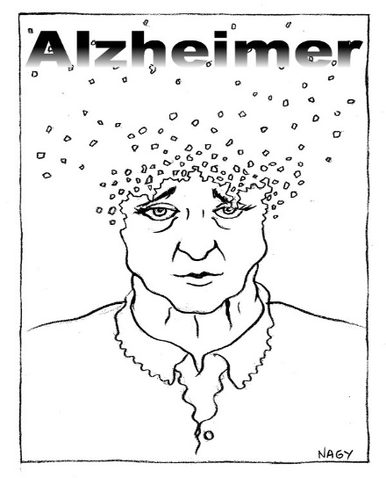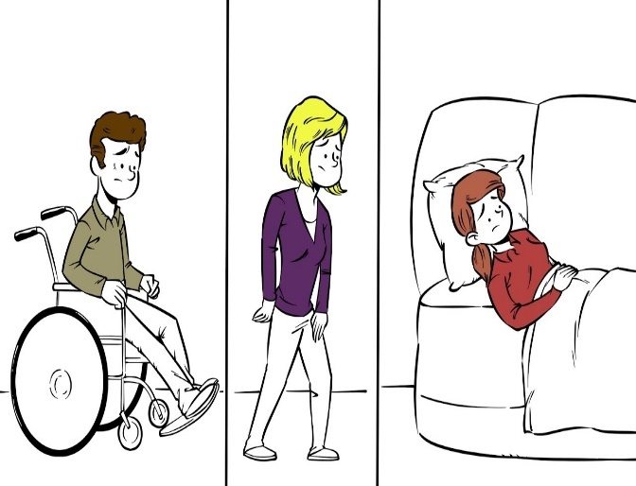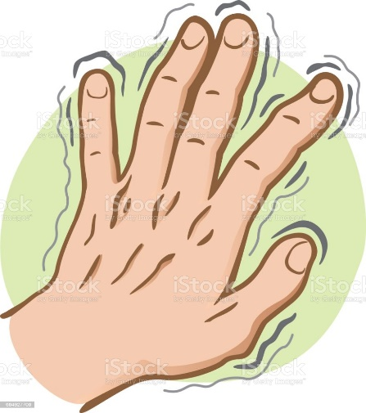

**Réponse :** _ _ _ _ _ _ _ _ _ _ _ _ _ _ _ _ _ _ _ _ _ _ _ _ _ _ _ _ _ _ _ _ _ _ _ _ _ _ _ _ _ _ _ _ _ _ _ _ _ _ _ _ _ _ _ _ _ _ _

**Quelles sont les différences entre les maladies citées ci-dessus ?**

* _ _ _ _ _ _ _ _ _ _ _ _ _ _ _ _ _ _ _ _ _ _ _ _ _ _ _ _ _ _ _ _ _ _ _ _ _ _ _ _ _ _ _ _ _ _ _ _ _ _ _ _ _ _ _ _ _ _ _
* _ _ _ _ _ _ _ _ _ _ _ _ _ _ _ _ _ _ _ _ _ _ _ _ _ _ _ _ _ _ _ _ _ _ _ _ _ _ _ _ _ _ _ _ _ _ _ _ _ _ _ _ _ _ _ _ _ _ _
* _ _ _ _ _ _ _ _ _ _ _ _ _ _ _ _ _ _ _ _ _ _ _ _ _ _ _ _ _ _ _ _ _ _ _ _ _ _ _ _ _ _ _ _ _ _ _ _ _ _ _ _ _ _ _ _ _ _ _
* _ _ _ _ _ _ _ _ _ _ _ _ _ _ _ _ _ _ _ _ _ _ _ _ _ _ _ _ _ _ _ _ _ _ _ _ _ _ _ _ _ _ _ _ _ _ _ _ _ _ _ _ _ _ _ _ _ _ _
* _ _ _ _ _ _ _ _ _ _ _ _ _ _ _ _ _ _ _ _ _ _ _ _ _ _ _ _ _ _ _ _ _ _ _ _ _ _ _ _ _ _ _ _ _ _ _ _ _ _ _ _ _ _ _ _ _ _ _

**Votre réponse :**

**Vous intervenez chez une personne atteinte de la maladie d’Alzheimer, vous allez être plus vigilant à quel risque ?**

**Votre réponse :**

* _ _ _ _ _ _ _ _ _ _ _ _ _ _ _ _ _ _ _ _ _ _ _ _ _ _ _ _ _ _ _ _ _ _ _ _ _ _

**Quels sont les dangers que la personne atteinte de la maladie d’Alzheimer peut rencontrer à son domicile ou en structure ‘Ehpad’ ?**

**Votre réponse :**

**Domicile :**

* _ _ _ _ _ _ _ _ _ _ _ _ _ _ _ _ _ _ _ _ _ _ _ _ _ _ _ _ _ _ _ _ _ _ _ _ _ _ _ _ _
* _ _ _ _ _ _ _ _ _ _ _ _ _ _ _ _ _ _ _ _ _ _ _ _ _ _ _ _ _ _ _ _ _ _ _ _ _ _ _ _ _
* _ _ _ _ _ _ _ _ _ _ _ _ _ _ _ _ _ _ _ _ _ _ _ _ _ _ _ _ _ _ _ _ _ _ _ _ _ _ _ _ _
* _ _ _ _ _ _ _ _ _ _ _ _ _ _ _ _ _ _ _ _ _ _ _ _ _ _ _ _ _ _ _ _ _ _ _ _ _ _ _ _ _

**Structure :**

* _ _ _ _ _ _ _ _ _ _ _ _ _ _ _ _ _ _ _ _ _ _ _ _ _ _ _ _ _ _ _ _ _ _ _ _ _ _ _ _ _
* _ _ _ _ _ _ _ _ _ _ _ _ _ _ _ _ _ _ _ _ _ _ _ _ _ _ _ _ _ _ _ _ _ _ _ _ _ _ _ _
* _ _ _ _ _ _ _ _ _ _ _ _ _ _ _ _ _ _ _ _ _ _ _ _ _ _ _ _ _ _ _ _ _ _ _ _ _ _ _ _ _
* _ _ _ _ _ _ _ _ _ _ _ _ _ _ _ _ _ _ _ _ _ _ _ _ _ _ _ _ _ _ _ _ _ _ _ _ _ _ _ _ _
* _ _ _ _ _ _ _ _ _ _ _ _ _ _ _ _ _ _ _ _ _ _ _ _ _ _ _ _ _ _ _ _ _ _ _ _ _ _ _ _ _



**Vous tentez de communiquer avec la personne atteinte de la maladie d’Alzheimer, quelle est votre approche ?**

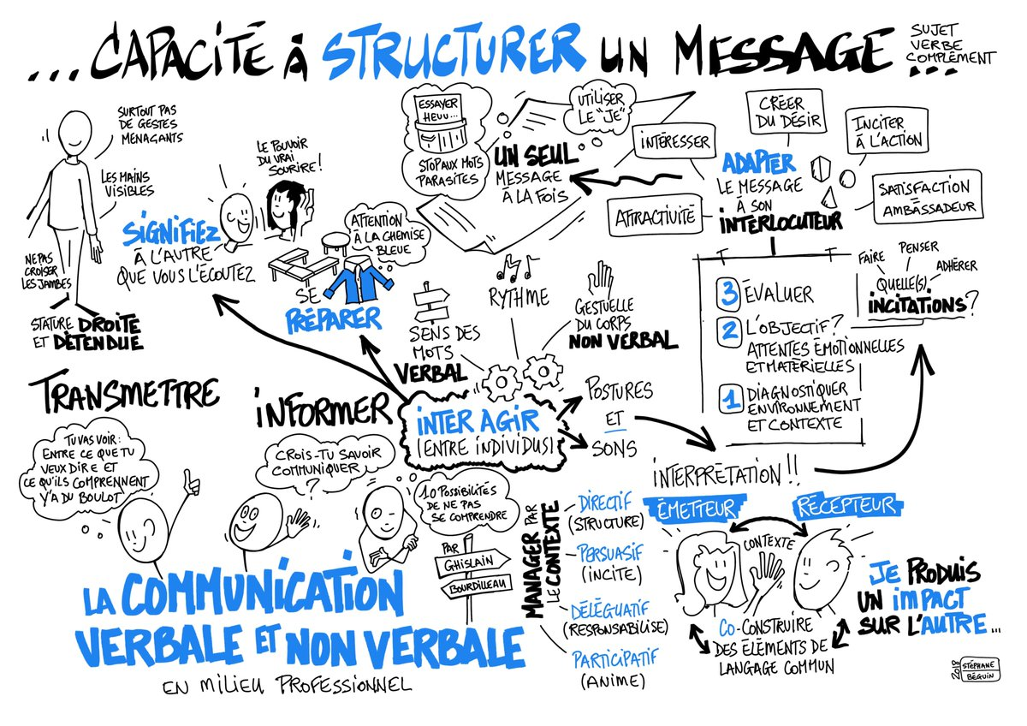

**Votre réponse :**

* _ _ _ _ _ _ _ _ _ _ _ _ _ _ _ _ _ _ _ _ _ _ _ _ _ _ _ _ _ _ _ _ _ _ _ _ _ _ _ _ _ _ _ _ _ _ _ _ _ _ _ _ _ _ _ _ _ _ _ _ _
* _ _ _ _ _ _ _ _ _ _ _ _ _ _ _ _ _ _ _ _ _ _ _ _ _ _ _ _ _ _ _ _ _ _ _ _ _ _ _ _ _ _ _ _ _ _ _ _ _ _ _ _ _ _ _ _ _ _ _ _ _
* _ _ _ _ _ _ _ _ _ _ _ _ _ _ _ _ _ _ _ _ _ _ _ _ _ _ _ _ _ _ _ _ _ _ _ _ _ _ _ _ _ _ _ _ _ _ _ _ _ _ _ _ _ _ _ _ _ _ _ _ _
* _ _ _ _ _ _ _ _ _ _ _ _ _ _ _ _ _ _ _ _ _ _ _ _ _ _ _ _ _ _ _ _ _ _ _ _ _ _ _ _ _ _ _ _ _ _ _ _ _ _ _ _ _ _ _ _ _ _ _ _ _
* _ _ _ _ _ _ _ _ _ _ _ _ _ _ _ _ _ _ _ _ _ _ _ _ _ _ _ _ _ _ _ _ _ _ _ _ _ _ _ _ _ _ _ _ _ _ _ _ _ _ _ _ _ _ _ _ _ _ _ _ _
* _ _ _ _ _ _ _ _ _ _ _ _ _ _ _ _ _ _ _ _ _ _ _ _ _ _ _ _ _ _ _ _ _ _ _ _ _ _ _ _ _ _ _ _ _ _ _ _ _ _ _ _ _ _ _ _ _ _ _ _ _
* _ _ _ _ _ _ _ _ _ _ _ _ _ _ _ _ _ _ _ _ _ _ _ _ _ _ _ _ _ _ _ _ _ _ _ _ _ _ _ _ _ _ _ _ _ _ _ _ _ _ _ _ _ _ _ _ _ _ _ _ _
* _ _ _ _ _ _ _ _ _ _ _ _ _ _ _ _ _ _ _ _ _ _ _ _ _ _ _ _ _ _ _ _ _ _ _ _ _ _ _ _ _ _ _ _ _ _ _ _ _ _ _ _ _ _ _ _ _ _ _ _ _
* _ _ _ _ _ _ _ _ _ _ _ _ _ _ _ _ _ _ _ _ _ _ _ _ _ _ _ _ _ _ _ _ _ _ _ _ _ _ _ _ _ _ _ _ _ _ _ _ _ _ _ _ _ _ _ _ _ _ _ _ _
* _ _ _ _ _ _ _ _ _ _ _ _ _ _ _ _ _ _ _ _ _ _ _ _ _ _ _ _ _ _ _ _ _ _ _ _ _ _ _ _ _ _ _ _ _ _ _ _ _ _ _ _ _ _ _ _ _ _ _ _ _
* _ _ _ _ _ _ _ _ _ _ _ _ _ _ _ _ _ _ _ _ _ _ _ _ _ _ _ _ _ _ _ _ _ _ _ _ _ _ _ _ _ _ _ _ _ _ _ _ _ _ _ _ _ _ _ _ _ _ _ _ _
* _ _ _ _ _ _ _ _ _ _ _ _ _ _ _ _ _ _ _ _ _ _ _ _ _ _ _ _ _ _ _ _ _ _ _ _ _ _ _ _ _ _ _ _ _ _ _ _ _ _ _ _ _ _ _ _ _ _ _ _ _

* _ _ _ _ _ _ _ _ _ _ _ _ _ _ _ _ _ _ _ _ _ _ _ _ _ _ _ _ _ _ _ _ _ _ _ _ _ _ _ _ _ _ _ _ _ _ _ _ _ _ _ _ _ _ _ _ _ _ _ _ _
* _ _ _ _ _ _ _ _ _ _ _ _ _ _ _ _ _ _ _ _ _ _ _ _ _ _ _ _ _ _ _ _ _ _ _ _ _ _ _ _ _ _ _ _ _ _ _ _ _ _ _ _ _ _ _ _ _ _ _ _ _

**Que veulent dire les termes ci-dessous ?**

* Aphasie : _ _ _ _ _ _ _ _ _ _ _ _ _ _ _ _ _ _ _ _ _ _ _ _ _ _ _ _ _ _ _ _ _ _ _ _ _ _ _ _ _ _ _ _ _ _ _ _ _ _ _ _ _ _ _

_ _ _ _ _ _ _ _ _ _ _ _ _ _ _ _ _ _ _ _ _ _ _ _ _ _ _ _ _ _ _ _ _ _ _ _ _ _ _ _ _ _ _ _ _ _ _ _ _ _ _ _ _ _ _ _ _ _ _ _ _

* Agnosie : _ _ _ _ _ _ _ _ _ _ _ _ _ _ _ _ _ _ _ _ _ _ _ _ _ _ _ _ _ _ _ _ _ _ _ _ _ _ _ _ _ _ _ _ _ _ _ _ _ _ _ _ _ _ _

_ _ _ _ _ _ _ _ _ _ _ _ _ _ _ _ _ _ _ _ _ _ _ _ _ _ _ _ _ _ _ _ _ _ _ _ _ _ _ _ _ _ _ _ _ _ _ _ _ _ _ _ _ _ _ _ _ _ _ _ _

* Apraxie : _ __ _ _ _ _ _ _ _ _ _ _ _ _ _ _ _ _ _ _ _ _ _ _ _ _ _ _ _ _ _ _ _ _ _ _ _ _ _ _ _ _ _ _ _ _ _ _ _ _ _ _ _ _ _

_ _ _ _ _ _ _ _ _ _ _ _ _ _ _ _ _ _ _ _ _ _ _ _ _ _ _ _ _ _ _ _ _ _ _ _ _ _ _ _ _ _ _ _ _ _ _ _ _ _ _ _ _ _ _ _ _ _ _ _ _

**Combien y a-t-il de stade dans la maladie d’Alzheimer ?**

**Votre réponse :**

* _ _ _ _ _ _ _ _ _ _ _ _ _ _ _ _ _ _ _ _ _ _ _ _ _ _ _ _ _ _ _ _ _ _ _ _ _ _ _ _ _ _ _ _ _ _ _ _ _ _ _ _ _ _ _ _ _ _ _
* _ _ _ _ _ _ _ _ _ _ _ _ _ _ _ _ _ _ _ _ _ _ _ _ _ _ _ _ _ _ _ _ _ _ _ _ _ _ _ _ _ _ _ _ _ _ _ _ _ _ _ _ _ _ _ _ _ _ _
* _ _ _ _ _ _ _ _ _ _ _ _ _ _ _ _ _ _ _ _ _ _ _ _ _ _ _ _ _ _ _ _ _ _ _ _ _ _ _ _ _ _ _ _ _ _ _ _ _ _ _ _ _ _ _ _ _ _ _
* _ _ _ _ _ _ _ _ _ _ _ _ _ _ _ _ _ _ _ _ _ _ _ _ _ _ _ _ _ _ _ _ _ _ _ _ _ _ _ _ _ _ _ _ _ _ _ _ _ _ _ _ _ _ _ _ _ _ _
* _ _ _ _ _ _ _ _ _ _ _ _ _ _ _ _ _ _ _ _ _ _ _ _ _ _ _ _ _ _ _ _ _ _ _ _ _ _ _ _ _ _ _ _ _ _ _ _ _ _ _ _ _ _ _ _ _ _ __ _
* _ _ _ _ _ _ _ _ _ _ _ _ _ _ _ _ _ _ _ _ _ _ _ _ _ _ _ _ _ _ _ _ _ _ _ _ _ _ _ _ _ _ _ _ _ _ _ _ _ _ _ _ _ _ _ _ _ _ _
* _ _ _ _ _ _ _ _ _ _ _ _ _ _ _ _ _ _ _ _ _ _ _ _ _ _ _ _ _ _ _ _ _ _ _ _ _ _ _ _ _ _ _ _ _ _ _ _ _ _ _ _ _ _ _ _ _ _ _
* _ _ _ _ _ _ _ _ _ _ _ _ _ _ _ _ _ _ _ _ _ _ _ _ _ _ _ _ _ _ _ _ _ _ _ _ _ _ _ _ _ _ _ _ _ _ _ _ _ _ _ _ _ _ _ _ _ _ __ _
* _ _ _ _ _ _ _ _ _ _ _ _ _ _ _ _ _ _ _ _ _ _ _ _ _ _ _ _ _ _ _ _ _ _ _ _ _ _ _ _ _ _ _ _ _ _ _ _ _ _ _ _ _ _ _ _ _ _ _
* _ _ _ _ _ _ _ _ _ _ _ _ _ _ _ _ _ _ _ _ _ _ _ _ _ _ _ _ _ _ _ _ _ _ _ _ _ _ _ _ _ _ _ _ _ _ _ _ _ _ _ _ _ _ _ _ _ _ _
* _ _ _ _ _ _ _ _ _ _ _ _ _ _ _ _ _ _ _ _ _ _ _ _ _ _ _ _ _ _ _ _ _ _ _ _ _ _ _ _ _ _ _ _ _ _ _ _ _ _ _ _ _ _ _ _ _ _ _
* _ _ _ _ _ _ _ _ _ _ _ _ _ _ _ _ _ _ _ _ _ _ _ _ _ _ _ _ _ _ _ _ _ _ _ _ _ _ _ _ _ _ _ _ _ _ _ _ _ _ _ _ _ _ _ _ _ _

**Quelle serait l’action à mener auprès de la personne atteinte de la maladie d’Alzheimer ?**

**Votre réponse :**

* _ _ _ _ _ _ _ _ _ _ _ _ _ _ _ _ _ _ _ _ _ _ _ _ _ _ _ _ _ _ _ _ _ _ _ _ _ _ _ _ _ _ _ _ _ _ _ _ _ _ _ _ _ _ _ _ _ _ _
* _ _ _ _ _ _ _ _ _ _ _ _ _ _ _ _ _ _ _ _ _ _ _ _ _ _ _ _ _ _ _ _ _ _ _ _ _ _ _ _ _ _ _ _ _ _ _ _ _ _ _ _ _ _ _ _ _ _ _
* _ _ _ _ _ _ _ _ _ _ _ _ _ _ _ _ _ _ _ _ _ _ _ _ _ _ _ _ _ _ _ _ _ _ _ _ _ _ _ _ _ _ _ _ _ _ _ _ _ _ _ _ _ _ _ _ _ _ _
* _ _ _ _ _ _ _ _ _ _ _ _ _ _ _ _ _ _ _ _ _ _ _ _ _ _ _ _ _ _ _ _ _ _ _ _ _ _ _ _ _ _ _ _ _ _ _ _ _ _ _ _ _ _ _ _ _ _ _
* _ _ _ _ _ _ _ _ _ _ _ _ _ _ _ _ _ _ _ _ _ _ _ _ _ _ _ _ _ _ _ _ _ _ _ _ _ _ _ _ _ _ _ _ _ _ _ _ _ _ _ _ _ _ _ _ _ _ _



**Vous intervenez chez une personne atteinte de la maladie de Parkinson, vous allez être plus vigilant à quel risque ?**

**Votre réponse :**

* _ _ _ _ _ _ _ _ _ _ _ _ _ _ _ _ _ _ _ _ _ _ _ _ _ _ _ _ _ _ _ _ _ _ _ _ _ _
* _ _ _ _ _ _ _ _ _ _ _ _ _ _ _ _ _ _ _ _ _ _ _ _ _ _ _ _ _ _ _ _ _ _ _ _ _ _
* _ _ _ _ _ _ _ _ _ _ _ _ _ _ _ _ _ _ _ _ _ _ _ _ _ _ _ _ _ _ _ _ _ _ _ _ _ _
* _ _ _ _ _ _ _ _ _ _ _ _ _ _ _ _ _ _ _ _ _ _ _ _ _ _ _ _ _ _ _ _ _ _ _ _ _ _
* _ _ _ _ _ _ _ _ _ _ _ _ _ _ _ _ _ _ _ _ _ _ _ _ _ _ _ _ _ _ _ _ _ _ _ _ _ _
* _ _ _ _ _ _ _ _ _ _ _ _ _ _ _ _ _ _ _ _ _ _ _ _ _ _ _ _ _ _ _ _ _ _ _ _ _ _
* _ _ _ _ _ _ _ _ _ _ _ _ _ _ _ _ _ _ _ _ _ _ _ _ _ _ _ _ _ _ _ _ _ _ _ _ _



**Quels sont les dangers que la personne atteinte de la maladie de Parkinson peut rencontrer à son domicile ou en structure ‘Ehpad’ ?**

**Votre réponse :**

**Domicile :**

* _ _ _ _ _ _ _ _ _ _ _ _ _ _ _ _ _ _ _ _ _ _ _ _ _ _ _ _ _ _ _ _ _ _ _ _ _ _ _ _ _
* _ _ _ _ _ _ _ _ _ _ _ _ _ _ _ _ _ _ _ _ _ _ _ _ _ _ _ _ _ _ _ _ _ _ _ _ _ _ _ _ _
* _ _ _ _ _ _ _ _ _ _ _ _ _ _ _ _ _ _ _ _ _ _ _ _ _ _ _ _ _ _ _ _ _ _ _ _ _ _ _ _ _
* _ _ _ _ _ _ _ _ _ _ _ _ _ _ _ _ _ _ _ _ _ _ _ _ _ _ _ _ _ _ _ _ _ _ _ _ _ _ _ _ _

**Structure :**

* _ _ _ _ _ _ _ _ _ _ _ _ _ _ _ _ _ _ _ _ _ _ _ _ _ _ _ _ _ _ _ _ _ _ _ _ _ _ _ _ _
* _ _ _ _ _ _ _ _ _ _ _ _ _ _ _ _ _ _ _ _ _ _ _ _ _ _ _ _ _ _ _ _ _ _ _ _ _ _ _ _ _
* _ _ _ _ _ _ _ _ _ _ _ _ _ _ _ _ _ _ _ _ _ _ _ _ _ _ _ _ _ _ _ _ _ _ _ _ _ _ _ _ _
* _ _ _ _ _ _ _ _ _ _ _ _ _ _ _ _ _ _ _ _ _ _ _ _ _ _ _ _ _ _ _ _ _ _ _ _ _ _ _ _ _



**Que veulent dire les termes ci-dessous ?**

* Akinésie : _ _ _ _ _ _ _ _ _ _ _ _ _ _ _ _ _ _ _ _ _ _ _ _ _ _ _ _ _ _ _ _ _ _ _ _ _ _ _ _ _ _ _ _ _ _ _ _ _ _ _ _ _ _ _
* Micrographie : _ _ _ _ _ _ _ _ _ _ _ _ _ _ _ _ _ _ _ _ _ _ _ _ _ _ _ _ _ _ _ _ _ _ _ _ _ _ _ _ _ _ _ _ _ _ _ _ _ _ _ _
* Asthénie : __ _ _ _ _ _ _ _ _ _ _ _ _ _ _ _ _ _ _ _ _ _ _ _ _ _ _ _ _ _ _ _ _ _ _ _ _ _ _ _ _ _ _ _ _ _ _ _ _ _ _ _ _ _

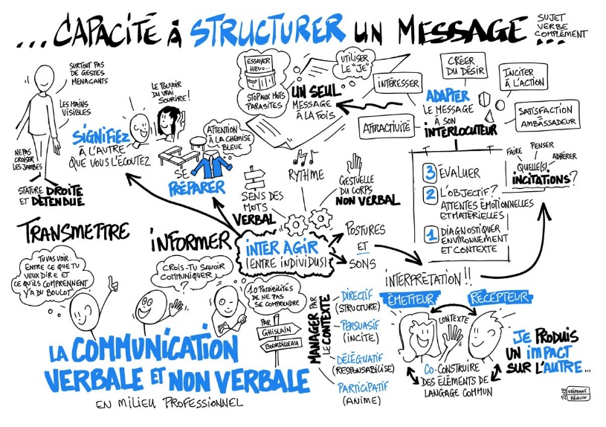**Pouvez-vous parler de la maladie de Parkinson avec la personne ? si oui, quelle est votre approche ?**

**Votre réponse :**

* _ _ _ _ _ _ _ _ _ _ _ _ _ _ _ _ _ _ _ _ _ _ _ _ _ _ _ _ _ _ _ _ _ _ _ _ _ _ _ _ _ _ _ _ _ _ _ _ _ _ _ _ _ _ _ _ _ _ _ _ _
* _ _ _ _ _ _ _ _ _ _ _ _ _ _ _ _ _ _ _ _ _ _ _ _ _ _ _ _ _ _ _ _ _ _ _ _ _ _ _ _ _ _ _ _ _ _ _ _ _ _ _ _ _ _ _ _ _ _ _ _ _
* _ _ _ _ _ _ _ _ _ _ _ _ _ _ _ _ _ _ _ _ _ _ _ _ _ _ _ _ _ _ _ _ _ _ _ _ _ _ _ _ _ _ _ _ _ _ _ _ _ _ _ _ _ _ _ _ _ _ _ _ _
* _ _ _ _ _ _ _ _ _ _ _ _ _ _ _ _ _ _ _ _ _ _ _ _ _ _ _ _ _ _ _ _ _ _ _ _ _ _ _ _ _ _ _ _ _ _ _ _ _ _ _ _ _ _ _ _ _ _ _ _ _
* _ _ _ _ _ _ _ _ _ _ _ _ _ _ _ _ _ _ _ _ _ _ _ _ _ _ _ _ _ _ _ _ _ _ _ _ _ _ _ _ _ _ _ _ _ _ _ _ _ _ _ _ _ _ _ _ _ _ _ _ _
* _ _ _ _ _ _ _ _ _ _ _ _ _ _ _ _ _ _ _ _ _ _ _ _ _ _ _ _ _ _ _ _ _ _ _ _ _ _ _ _ _ _ _ _ _ _ _ _ _ _ _ _ _ _ _ _ _ _ _ _ _
* _ _ _ _ _ _ _ _ _ _ _ _ _ _ _ _ _ _ _ _ _ _ _ _ _ _ _ _ _ _ _ _ _ _ _ _ _ _ _ _ _ _ _ _ _ _ _ _ _ _ _ _ _ _ _ _ _ _ _ _ _

**Quelle serait l’action à mener auprès de la personne atteinte de la maladie de Parkinson ?**

**Votre réponse :**

* _ _ _ _ _ _ _ _ _ _ _ _ _ _ _ _ _ _ _ _ _ _ _ _ _ _ _ _ _ _ _ _ _ _ _ _ _ _ _ _ _ _ _ _ _ _ _ _ _ _ _ _ _ _ _ _ _ _ _
* _ _ _ _ _ _ _ _ _ _ _ _ _ _ _ _ _ _ _ _ _ _ _ _ _ _ _ _ _ _ _ _ _ _ _ _ _ _ _ _ _ _ _ _ _ _ _ _ _ _ _ _ _ _ _ _ _ _ _
* _ _ _ _ _ _ _ _ _ _ _ _ _ _ _ _ _ _ _ _ _ _ _ _ _ _ _ _ _ _ _ _ _ _ _ _ _ _ _ _ _ _ _ _ _ _ _ _ _ _ _ _ _ _ _ _ _ _ _
* _ _ _ _ _ _ _ _ _ _ _ _ _ _ _ _ _ _ _ _ _ _ _ _ _ _ _ _ _ _ _ _ _ _ _ _ _ _ _ _ _ _ _ _ _ _ _ _ _ _ _ _ _ _ _ _ _ _ _
* _ _ _ _ _ _ _ _ _ _ _ _ _ _ _ _ _ _ _ _ _ _ _ _ _ _ _ _ _ _ _ _ _ _ _ _ _ _ _ _ _ _ _ _ _ _ _ _ _ _ _ _ _ _ _ _ _ _ _

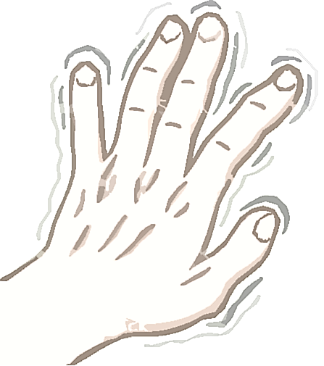

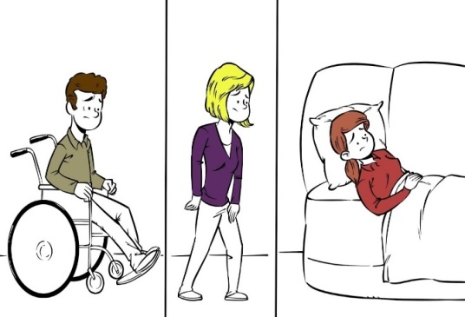**Vous intervenez chez une personne atteinte de la Sclérose En Plaque, vous allez être plus vigilant à quel risque ?**

**Votre réponse :**

* _ _ _ _ _ _ _ _ _ _ _ _ _ _ _ _ _ _ _ _ _ _ _ _ _ _ _ _ _ _ _ _ _ _ _ _ _ _ _ _ _ _ _ _ _ _ _ _ _ _ _ _ _ _ _ _ _ _ _ _ _
* _ _ _ _ _ _ _ _ _ _ _ _ _ _ _ _ _ _ _ _ _ _ _ _ _ _ _ _ _ _ _ _ _ _ _ _ _ _ _ _ _ _ _ _ _ _ _ _ _ _ _ _ _ _ _ _ _ _ _ _ _
* _ _ _ _ _ _ _ _ _ _ _ _ _ _ _ _ _ _ _ _ _ _ _ _ _ _ _ _ _ _ _ _ _ _ _ _ _ _ _ _ _ _ _ _ _ _ _ _ _ _ _ _ _ _ _ _ _ _ _ _ _
* _ _ _ _ _ _ _ _ _ _ _ _ _ _ _ _ _ _ _ _ _ _ _ _ _ _ _ _ _ _ _ _ _ _ _ _ _ _ _ _ _ _ _ _ _ _ _ _ _ _ _ _ _ _ _ _ _ _ _ _ _
* _ _ _ _ _ _ _ _ _ _ _ _ _ _ _ _ _ _ _ _ _ _ _ _ _ _ _ _ _ _ _ _ _ _ _ _ _ _ _ _ _ _ _ _ _ _ _ _ _ _ _ _ _ _ _ _ _ _ _ _ _

**Quels sont les dangers que la personne ayant la SEP peut rencontrer à son domicile ou en structure ‘Ehpad’ ?**

**Votre réponse :**

**Domicile :**

* _ _ _ _ _ _ _ _ _ _ _ _ _ _ _ _ _ _ _ _ _ _ _ _ _ _ _ _ _ _ _ _ _ _ _ _ _ _ _ _ _
* _ _ _ _ _ _ _ _ _ _ _ _ _ _ _ _ _ _ _ _ _ _ _ _ _ _ _ _ _ _ _ _ _ _ _ _ _ _ _ _ _
* _ _ _ _ _ _ _ _ _ _ _ _ _ _ _ _ _ _ _ _ _ _ _ _ _ _ _ _ _ _ _ _ _ _ _ _ _ _ _ _ _
* _ _ _ _ _ _ _ _ _ _ _ _ _ _ _ _ _ _ _ _ _ _ _ _ _ _ _ _ _ _ _ _ _ _ _ _ _ _ _ _ _

**Structure :**

* _ _ _ _ _ _ _ _ _ _ _ _ _ _ _ _ _ _ _ _ _ _ _ _ _ _ _ _ _ _ _ _ _ _ _ _ _ _ _ _ _
* _ _ _ _ _ _ _ _ _ _ _ _ _ _ _ _ _ _ _ _ _ _ _ _ _ _ _ _ _ _ _ _ _ _ _ _ _ _ _ _ _
* _ _ _ _ _ _ _ _ _ _ _ _ _ _ _ _ _ _ _ _ _ _ _ _ _ _ _ _ _ _ _ _ _ _ _ _ _ _ _ _ _
* _ _ _ _ _ _ _ _ _ _ _ _ _ _ _ _ _ _ _ _ _ _ _ _ _ _ _ _ _ _ _ _ _ _ _ _ _ _ _ _ _



**Que veulent dire les termes ci-dessous ?**

* Poussée : _ _ _ _ _ _ _ _ _ _ _ _ _ _ _ _ _ _ _ _ _ _ _ _ _ _ _ _ _ _ _ _ _ _ _ _ _ _ _ _ _ _ _ _ _ _ _ _ _ _ _ _ _ _ _
* Acuité visuelle : _ _ _ _ _ _ _ _ _ _ _ _ _ _ _ _ _ _ _ _ _ _ _ _ _ _ _ _ _ _ _ _ _ _ _ _ _ _ _ _ _ _ _ _ _ _ _ _ _ _ _ _
* Diminution sensitive : __ _ _ _ _ _ _ _ _ _ _ _ _ _ _ _ _ _ _ _ _ _ _ _ _ _ _ _ _ _ _ _ _ _ _ _ _ _ _ _ _ _ _ _ _ _ _

**Pouvez-vous parler de la SEP avec la personne ? si oui, quelle est votre approche ?**

**Votre réponse :**

* _ _ _ _ _ _ _ _ _ _ _ _ _ _ _ _ _ _ _ _ _ _ _ _ _ _ _ _ _ _ _ _ _ _ _ _ _ _ _ _ _ _ _ _ _ _ _ _ _ _ _ _ _ _ _ _ _ _ _ _ _
* _ _ _ _ _ _ _ _ _ _ _ _ _ _ _ _ _ _ _ _ _ _ _ _ _ _ _ _ _ _ _ _ _ _ _ _ _ _ _ _ _ _ _ _ _ _ _ _ _ _ _ _ _ _ _ _ _ _ _ _ _
* _ _ _ _ _ _ _ _ _ _ _ _ _ _ _ _ _ _ _ _ _ _ _ _ _ _ _ _ _ _ _ _ _ _ _ _ _ _ _ _ _ _ _ _ _ _ _ _ _ _ _ _ _ _ _ _ _ _ _ _ _
* _ _ _ _ _ _ _ _ _ _ _ _ _ _ _ _ _ _ _ _ _ _ _ _ _ _ _ _ _ _ _ _ _ _ _ _ _ _ _ _ _ _ _ _ _ _ _ _ _ _ _ _ _ _ _ _ _ _ _ _ _
* _ _ _ _ _ _ _ _ _ _ _ _ _ _ _ _ _ _ _ _ _ _ _ _ _ _ _ _ _ _ _ _ _ _ _ _ _ _ _ _ _ _ _ _ _ _ _ _ _ _ _ _ _ _ _ _ _ _ _ _ _
* _ _ _ _ _ _ _ _ _ _ _ _ _ _ _ _ _ _ _ _ _ _ _ _ _ _ _ _ _ _ _ _ _ _ _ _ _ _ _ _ _ _ _ _ _ _ _ _ _ _ _ _ _ _ _ _ _ _ _ _ _
* _ _ _ _ _ _ _ _ _ _ _ _ _ _ _ _ _ _ _ _ _ _ _ _ _ _ _ _ _ _ _ _ _ _ _ _ _ _ _ _ _ _ _ _ _ _ _ _ _ _ _ _ _ _ _ _ _ _ _ _ _

**Quelle serait l’action à mener auprès de la personne atteinte de la Sclérose En Plaque ?**

**Votre réponse :**

* _ _ _ _ _ _ _ _ _ _ _ _ _ _ _ _ _ _ _ _ _ _ _ _ _ _ _ _ _ _ _ _ _ _ _ _ _ _ _ _ _ _ _ _ _ _ _ _ _ _ _ _ _ _ _ _ _ _ _
* _ _ _ _ _ _ _ _ _ _ _ _ _ _ _ _ _ _ _ _ _ _ _ _ _ _ _ _ _ _ _ _ _ _ _ _ _ _ _ _ _ _ _ _ _ _ _ _ _ _ _ _ _ _ _ _ _ _ _
* _ _ _ _ _ _ _ _ _ _ _ _ _ _ _ _ _ _ _ _ _ _ _ _ _ _ _ _ _ _ _ _ _ _ _ _ _ _ _ _ _ _ _ _ _ _ _ _ _ _ _ _ _ _ _ _ _ _ _
* _ _ _ _ _ _ _ _ _ _ _ _ _ _ _ _ _ _ _ _ _ _ _ _ _ _ _ _ _ _ _ _ _ _ _ _ _ _ _ _ _ _ _ _ _ _ _ _ _ _ _ _ _ _ _ _ _ _ _
* _ _ _ _ _ _ _ _ _ _ _ _ _ _ _ _ _ _ _ _ _ _ _ _ _ _ _ _ _ _ _ _ _ _ _ _ _ _ _ _ _ _ _ _ _ _ _ _ _ _ _ _ _ _ _ _ _ _ _
* _ _ _ _ _ _ _ _ _ _ _ _ _ _ _ _ _ _ _ _ _ _ _ _ _ _ _ _ _ _ _ _ _ _ _ _ _ _ _ _ _ _ _ _ _ _ _ _ _ _ _ _ _ _ _ _ _ _ _



**Vous intervenez chez une personne vieillissante, vous allez être plus vigilant à quel risque ?**

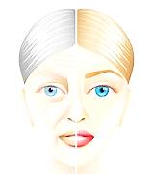

**Votre réponse :**

* _ _ _ _ _ _ _ _ _ _ _ _ _ _ _ _ _ _ _ _ _ _ _ _ _ _ _ _ _ _ _ _ _ _ _ _ _ _
* _ _ _ _ _ _ _ _ _ _ _ _ _ _ _ _ _ _ _ _ _ _ _ _ _ _ _ _ _ _ _ _ _ _ _ _ _ _
* _ _ _ _ _ _ _ _ _ _ _ _ _ _ _ _ _ _ _ _ _ _ _ _ _ _ _ _ _ _ _ _ _ _ _ _ _ _
* _ _ _ _ _ _ _ _ _ _ _ _ _ _ _ _ _ _ _ _ _ _ _ _ _ _ _ _ _ _ _ _ _ _ _ _ _ _
* _ _ _ _ _ _ _ _ _ _ _ _ _ _ _ _ _ _ _ _ _ _ _ _ _ _ _ _ _ _ _ _ _ _ _ _ _ _
* _ _ _ _ _ _ _ _ _ _ _ _ _ _ _ _ _ _ _ _ _ _ _ _ _ _ _ _ _ _ _ _ _ _ _ _ _ _
* _ _ _ _ _ _ _ _ _ _ _ _ _ _ _ _ _ _ _ _ _ _ _ _ _ _ _ _ _ _ _ _ _ _ _ _ _

**Quels sont les dangers que la personne vieillissante peut rencontrer à son domicile ou en structure ‘Ehpad’ ?**

**Votre réponse :**

* _ _ _ _ _ _ _ _ _ _ _ _ _ _ _ _ _ _ _ _ _ _ _ _ _ _ _ _ _ _ _ _ _ _ _ _ _ _ _ _ _
* _ _ _ _ _ _ _ _ _ _ _ _ _ _ _ _ _ _ _ _ _ _ _ _ _ _ _ _ _ _ _ _ _ _ _ _ _ _ _ _ _
* _ _ _ _ _ _ _ _ _ _ _ _ _ _ _ _ _ _ _ _ _ _ _ _ _ _ _ _ _ _ _ _ _ _ _ _ _ _ _ _ _
* _ _ _ _ _ _ _ _ _ _ _ _ _ _ _ _ _ _ _ _ _ _ _ _ _ _ _ _ _ _ _ _ _ _ _ _ _ _ _ _ _
* _ _ _ _ _ _ _ _ _ _ _ _ _ _ _ _ _ _ _ _ _ _ _ _ _ _ _ _ _ _ _ _ _ _ _ _ _ _ _ _ _
* _ _ _ _ _ _ _ _ _ _ _ _ _ _ _ _ _ _ _ _ _ _ _ _ _ _ _ _ _ _ _ _ _ _ _ _ _ _ _ _ _



**Que veulent dire les termes ci-dessous ?**

* Dégénérescences cellulaires : _ _ _ _ _ _ _ _ _ _ _ _ _ _ _ _ _ _ _ _ _ _ _ _ _ _ _ _ _ _ _ _ _ _ _ _ _ _ _ _ _ _ _ _
* Acuité auditif : _ _ _ _ _ _ _ _ _ _ _ _ _ _ _ _ _ _ _ _ _ _ _ _ _ _ _ _ _ _ _ _ _ _ _ _ _ _ _ _ _ _ _ _ _ _ _ _ _ _ _ _
* Déshydratation  : __ _ _ _ _ _ _ _ _ _ _ _ _ _ _ _ _ _ _ _ _ _ _ _ _ _ _ _ _ _ _ _ _ _ _ _ _ _ _ _ _ _ _ _ _ _ _

**Pouvez-vous parler du vieillissement avec la personne ? si oui, quelle est votre approche ?**

**Votre réponse :**

* _ _ _ _ _ _ _ _ _ _ _ _ _ _ _ _ _ _ _ _ _ _ _ _ _ _ _ _ _ _ _ _ _ _ _ _ _ _ _ _ _ _ _ _ _ _ _ _ _ _ _ _ _ _ _ _ _ _ _ _ _
* _ _ _ _ _ _ _ _ _ _ _ _ _ _ _ _ _ _ _ _ _ _ _ _ _ _ _ _ _ _ _ _ _ _ _ _ _ _ _ _ _ _ _ _ _ _ _ _ _ _ _ _ _ _ _ _ _ _ _ _ _
* _ _ _ _ _ _ _ _ _ _ _ _ _ _ _ _ _ _ _ _ _ _ _ _ _ _ _ _ _ _ _ _ _ _ _ _ _ _ _ _ _ _ _ _ _ _ _ _ _ _ _ _ _ _ _ _ _ _ _ _ _
* _ _ _ _ _ _ _ _ _ _ _ _ _ _ _ _ _ _ _ _ _ _ _ _ _ _ _ _ _ _ _ _ _ _ _ _ _ _ _ _ _ _ _ _ _ _ _ _ _ _ _ _ _ _ _ _ _ _ _ _ _
* _ _ _ _ _ _ _ _ _ _ _ _ _ _ _ _ _ _ _ _ _ _ _ _ _ _ _ _ _ _ _ _ _ _ _ _ _ _ _ _ _ _ _ _ _ _ _ _ _ _ _ _ _ _ _ _ _ _ _ _ _
* _ _ _ _ _ _ _ _ _ _ _ _ _ _ _ _ _ _ _ _ _ _ _ _ _ _ _ _ _ _ _ _ _ _ _ _ _ _ _ _ _ _ _ _ _ _ _ _ _ _ _ _ _ _ _ _ _ _ _ _ _
* _ _ _ _ _ _ _ _ _ _ _ _ _ _ _ _ _ _ _ _ _ _ _ _ _ _ _ _ _ _ _ _ _ _ _ _ _ _ _ _ _ _ _ _ _ _ _ _ _ _ _ _ _ _ _ _ _ _ _ _ _

**Quelle serait l’action à mener auprès de la personne vieillissante ?**

**Votre réponse :**

* _ _ _ _ _ _ _ _ _ _ _ _ _ _ _ _ _ _ _ _ _ _ _ _ _ _ _ _ _ _ _ _ _ _ _ _ _ _ _ _ _ _ _ _ _ _ _ _ _ _ _ _ _ _ _ _ _ _ _
* _ _ _ _ _ _ _ _ _ _ _ _ _ _ _ _ _ _ _ _ _ _ _ _ _ _ _ _ _ _ _ _ _ _ _ _ _ _ _ _ _ _ _ _ _ _ _ _ _ _ _ _ _ _ _ _ _ _ _
* _ _ _ _ _ _ _ _ _ _ _ _ _ _ _ _ _ _ _ _ _ _ _ _ _ _ _ _ _ _ _ _ _ _ _ _ _ _ _ _ _ _ _ _ _ _ _ _ _ _ _ _ _ _ _ _ _ _ _
* _ _ _ _ _ _ _ _ _ _ _ _ _ _ _ _ _ _ _ _ _ _ _ _ _ _ _ _ _ _ _ _ _ _ _ _ _ _ _ _ _ _ _ _ _ _ _ _ _ _ _ _ _ _ _ _ _ _ _
* _ _ _ _ _ _ _ _ _ _ _ _ _ _ _ _ _ _ _ _ _ _ _ _ _ _ _ _ _ _ _ _ _ _ _ _ _ _ _ _ _ _ _ _ _ _ _ _ _ _ _ _ _ _ _ _ _ _ _
* _ _ _ _ _ _ _ _ _ _ _ _ _ _ _ _ _ _ _ _ _ _ _ _ _ _ _ _ _ _ _ _ _ _ _ _ _ _ _ _ _ _ _ _ _ _ _ _ _ _ _ _ _ _ _ _ _ _ _

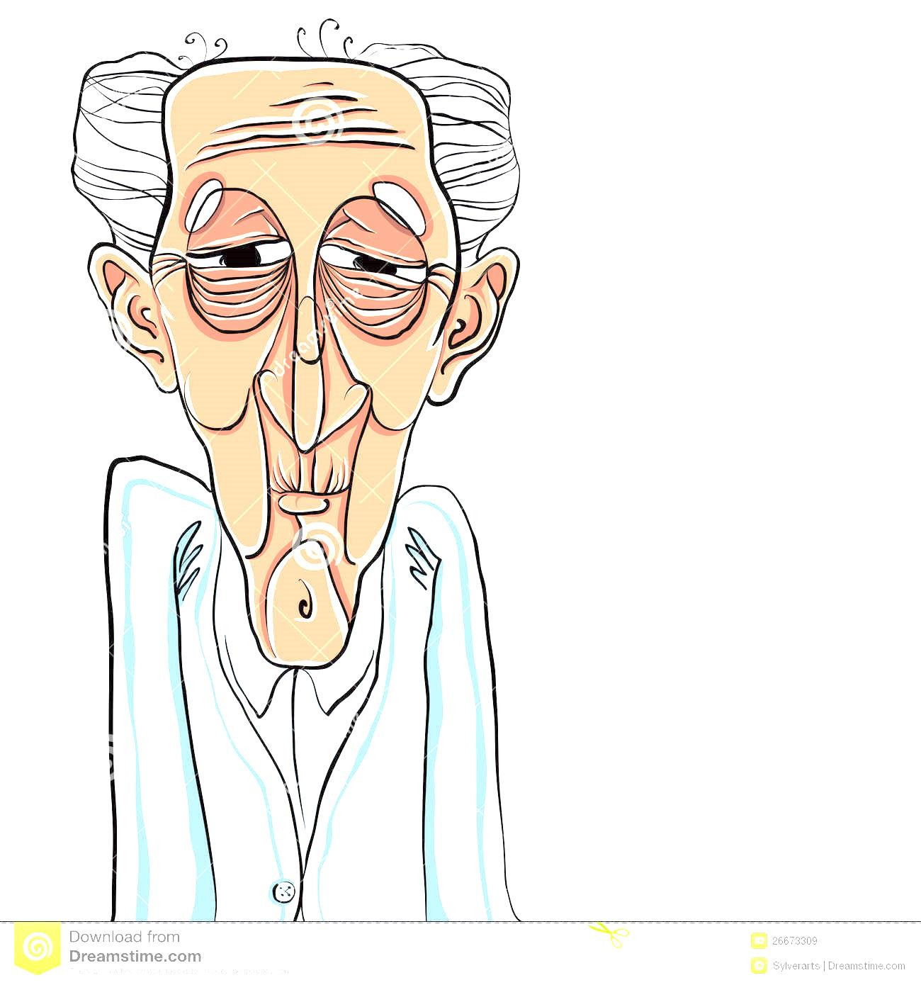

**Reliez les points entre les maladies et les symptômes :**

|  |  |
| --- | --- |
| **La maladie de Parkinson** | **Apraxie :** une incapacité à effectuer certains gestes, en particulier à manipuler des objets de la vie quotidienne ;  **Aphasie :** troubles du langage comme la capacité  à nommer des objets, le manque de mots, la compréhension et l’écriture ;   * **agnosie :** des troubles de la reconnaissance d’objets ; * une **désorientation spatiale** * Et des **troubles du raisonnement et de la planification**. |
| **La maladie d’Alzheimer** | Les effets sont donc multiples : L'activité du système nerveux central : La baisse du nombre de neurones dans le cerveau et les troubles de la circulation cérébrale entraînent des pertes de mémoire et des difficultés à se concentrer |
| **La SEP : Sclérose En Plaque** | De sensations  de**fourmillement**, **d’engourdissement, de peau cartonnée, d’eau coulant sur le corps, de piqûres**, **de brûlure ou de froid ;**  D’un signe appelé **« signe de L’Hermite »** : impression de **décharge électrique le long de la colonne vertébrale et/ou des membres, qui survient uniquement lors de la flexion de la nuque** ;  D’une **baisse de la perception sensitive ;**  **De douleurs.** |
| **Le vieillissement** | Premiers signes unilatéraux, ne gênant pas la vie quotidienne.  Signes encore unilatéraux, mais entraînant  une **gêne**.  Signes bilatéraux, posture modifiée, pas de handicap grave, **autonomie** complète.  **Handicap** plus sévère, marche encore possible, autonomie limitée.  Marche impossible (fauteuil roulant, alitement), **perte complète de l’autonomie.** |

**La fracture du col du fémur est-il un problème rare chez la personne âgée ?**

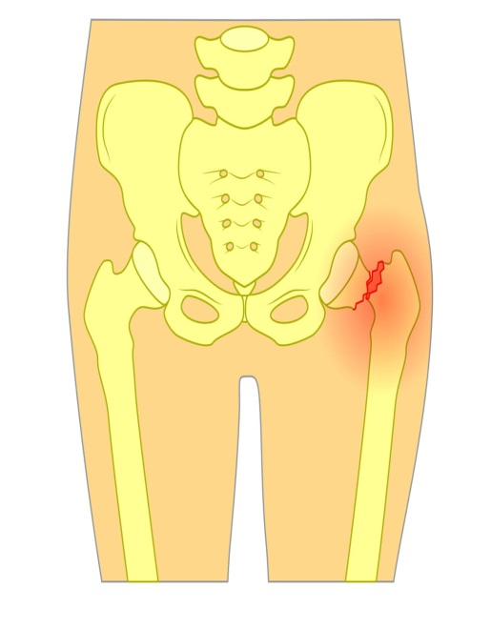**Votre réponse :**

* _ _ _ _ _ _ _ _ _ _ _ _ _ _ _ _ _ _ _ _ _ _ _ _ _ _ _ _ _ _ _ _ _ _ _ _ _ _ _ _ _
* _ _ _ _ _ _ _ _ _ _ _ _ _ _ _ _ _ _ _ _ _ _ _ _ _ _ _ _ _ _ _ _ _ _ _ _ _ _ _ _ _
* _ _ _ _ _ _ _ _ _ _ _ _ _ _ _ _ _ _ _ _ _ _ _ _ _ _ _ _ _ _ _ _ _ _ _ _ _ _ _ _ _
* _ _ _ _ _ _ _ _ _ _ _ _ _ _ _ _ _ _ _ _ _ _ _ _ _ _ _ _ _ _ _ _ _ _ _ _ _ _ _ _ _
* _ _ _ _ _ _ _ _ _ _ _ _ _ _ _ _ _ _ _ _ _ _ _ _ _ _ _ _ _ _ _ _ _ _ _ _ _ _ _ _ _
* _ _ _ _ _ _ _ _ _ _ _ _ _ _ _ _ _ _ _ _ _ _ _ _ _ _ _ _ _ _ _ _ _ _ _ _ _ _ _ _ _

**Ce type d’accident arrive dans quelle circonstance ?**

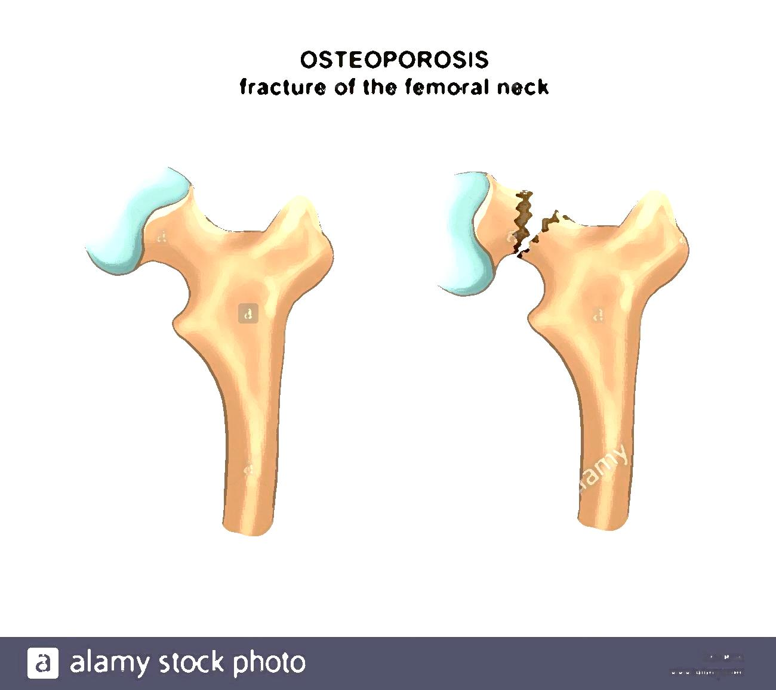**Votre réponse :**

* _ _ _ _ _ _ _ _ _ _ _ _ _ _ _ _ _ _ _ _ _ _ _ _ _ _ _ _ _ _ _ _ _ _ _ _ _ _ _ _ _
* _ _ _ _ _ _ _ _ _ _ _ _ _ _ _ _ _ _ _ _ _ _ _ _ _ _ _ _ _ _ _ _ _ _ _ _ _ _ _ _ _
* _ _ _ _ _ _ _ _ _ _ _ _ _ _ _ _ _ _ _ _ _ _ _ _ _ _ _ _ _ _ _ _ _ _ _ _ _ _ _ _ _
* _ _ _ _ _ _ _ _ _ _ _ _ _ _ _ _ _ _ _ _ _ _ _ _ _ _ _ _ _ _ _ _ _ _ _ _ _ _ _ _ _
* _ _ _ _ _ _ _ _ _ _ _ _ _ _ _ _ _ _ _ _ _ _ _ _ _ _ _ _ _ _ _ _ _ _ _ _ _ _ _ _ _
* _ _ _ _ _ _ _ _ _ _ _ _ _ _ _ _ _ _ _ _ _ _ _ _ _ _ _ _ _ _ _ _ _ _ _ _ _ _ _ _ _

**Pour éviter ce type d’accident que pourriez-vous faire ? Comment ? Avec qui ?**

.

* _ _ _ _ _ _ _ _ _ _ _ _ _ _ _ _ _ _ _ _ _ _ _ _ _ _ _ _ _ _ _ _ _ _ _ _ _ _ _ _ _
* _ _ _ _ _ _ _ _ _ _ _ _ _ _ _ _ _ _ _ _ _ _ _ _ _ _ _ _ _ _ _ _ _ _ _ _ _ _ _ _ _
* _ _ _ _ _ _ _ _ _ _ _ _ _ _ _ _ _ _ _ _ _ _ _ _ _ _ _ _ _ _ _ _ _ _ _ _ _ _ _ _ _
* _ _ _ _ _ _ _ _ _ _ _ _ _ _ _ _ _ _ _ _ _ _ _ _ _ _ _ _ _ _ _ _ _ _ _ _ _ _ _ _ _
* _ _ _ _ _ _ _ _ _ _ _ _ _ _ _ _ _ _ _ _ _ _ _ _ _ _ _ _ _ _ _ _ _ _ _ _ _ _ _ _ _
* _ _ _ _ _ _ _ _ _ _ _ _ _ _ _ _ _ _ _ _ _ _ _ _ _ _ _ _ _ _ _ _ _ _ _ _ _ _ _ _ _

**Votre réponse :**

**Que veut dire P.T.H**

**Votre réponse : _ _ _ _ _ _ _ _ _ _ _ _ _ _ _ _ _ _ _ _ _ _ _ _ _ _ _ _ _ _ _ _ _ _ _ _ _ _ _ _ _ _ _ _**

**Une personne ayant subi une P.T.H peut-elle se remettre debout et remarcher ?**

**Votre réponse : _ _ _ _ _ _ _ _ _ _ _ _ _ _ _ _ _ _ _ _ _ _ _ _ _ _ _ _ _ _ _ _ _ _ _ _ _ _ _ _ _ _ _ _**

**Quelles sont les difficultés d’une personne atteinte d’Arthrose dans les gestes de son quotidien ?**

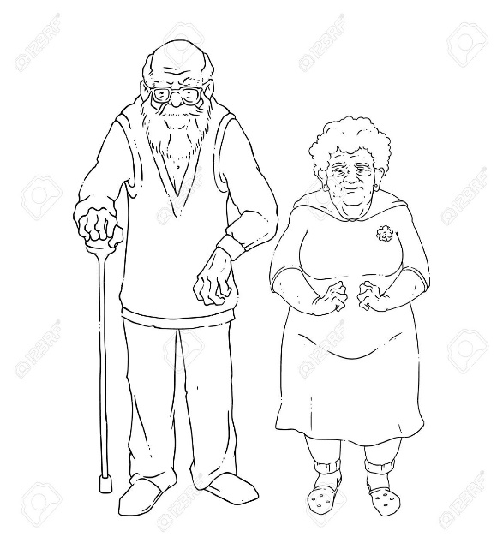**Votre réponse :**

* _ _ _ _ _ _ _ _ _ _ _ _ _ _ _ _ _ _ _ _ _ _ _ _ _ _ _ _ _ _ _ _ _ _ _ _ _ _ _ _ _
* _ _ _ _ _ _ _ _ _ _ _ _ _ _ _ _ _ _ _ _ _ _ _ _ _ _ _ _ _ _ _ _ _ _ _ _ _ _ _ _ _
* _ _ _ _ _ _ _ _ _ _ _ _ _ _ _ _ _ _ _ _ _ _ _ _ _ _ _ _ _ _ _ _ _ _ _ _ _ _ _ _ _
* _ _ _ _ _ _ _ _ _ _ _ _ _ _ _ _ _ _ _ _ _ _ _ _ _ _ _ _ _ _ _ _ _ _ _ _ _ _ _ _ _
* _ _ _ _ _ _ _ _ _ _ _ _ _ _ _ _ _ _ _ _ _ _ _ _ _ _ _ _ _ _ _ _ _ _ _ _ _ _ _ _ _
* _ _ _ _ _ _ _ _ _ _ _ _ _ _ _ _ _ _ _ _ _ _ _ _ _ _ _ _ _ _ _ _ _ _ _ _ _ _ _ _ _

**Existe-t-il d’autres formes d’arthrose handicapante qui peuvent gêner le quotidien d’une personne ?**

**Votre réponse :**

* _ _ _ _ _ _ _ _ _ _ _ _ _ _ _ _ _ _ _ _ _ _ _ _ _ _ _ _ _ _ _ _ _ _ _ _ _ _ _ _ _
* _ _ _ _ _ _ _ _ _ _ _ _ _ _ _ _ _ _ _ _ _ _ _ _ _ _ _ _ _ _ _ _ _ _ _ _ _ _ _ _ _
* _ _ _ _ _ _ _ _ _ _ _ _ _ _ _ _ _ _ _ _ _ _ _ _ _ _ _ _ _ _ _ _ _ _ _ _ _ _ _ _ _
* _ _ _ _ _ _ _ _ _ _ _ _ _ _ _ _ _ _ _ _ _ _ _ _ _ _ _ _ _ _ _ _ _ _ _ _ _ _ _ _ _
* _ _ _ _ _ _ _ _ _ _ _ _ _ _ _ _ _ _ _ _ _ _ _ _ _ _ _ _ _ _ _ _ _ _ _ _ _ _ _ _ _
* _ _ _ _ _ _ _ _ _ _ _ _ _ _ _ _ _ _ _ _ _ _ _ _ _ _ _ _ _ _ _ _ _ _ _ _ _ _ _ _ _

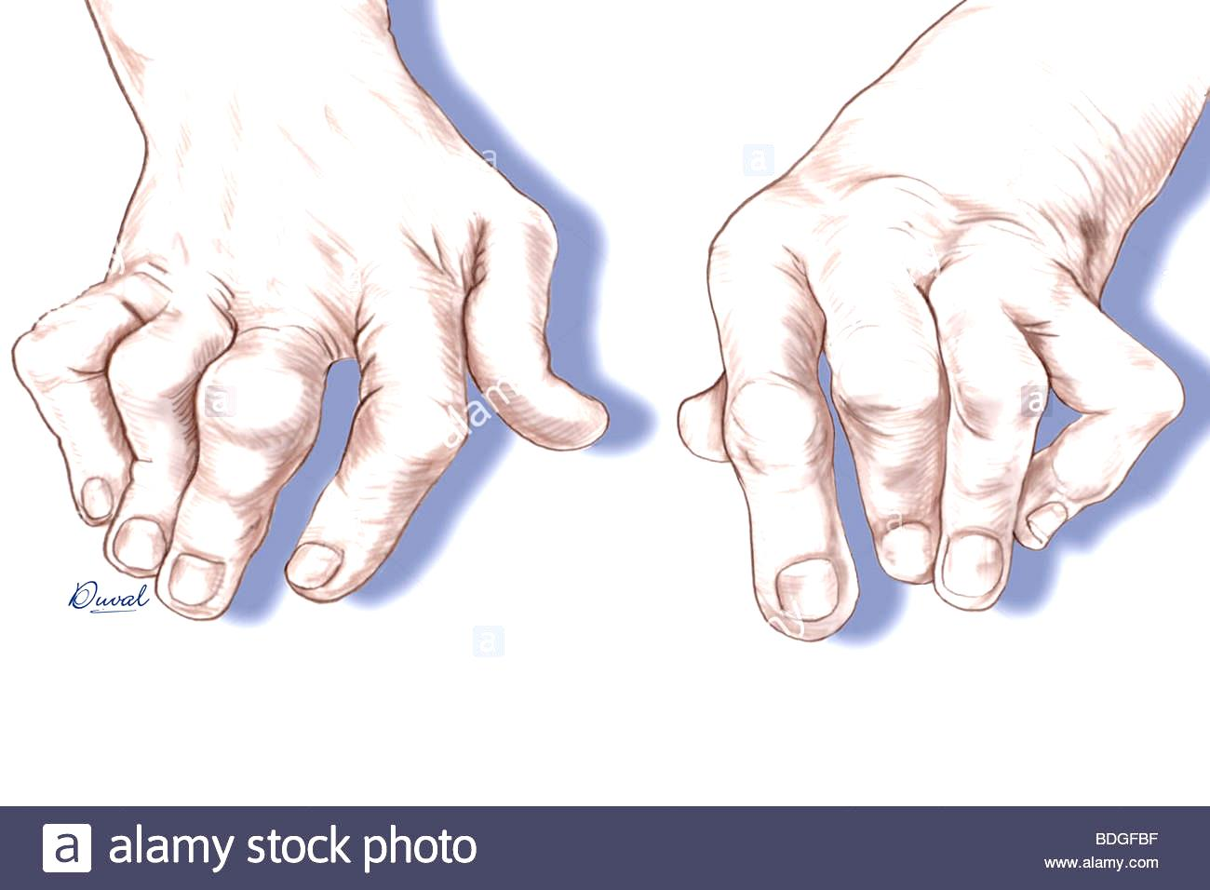

**Les étapes du deuil, combien en existe-t-il ?**

|  |  |
| --- | --- |
| Les étapes : | L’explication : |
|  |  |
|  |  |
|  |  |
|  |  |
|  |  |
|  |  |
|  |  |
|  |  |
|  |  |

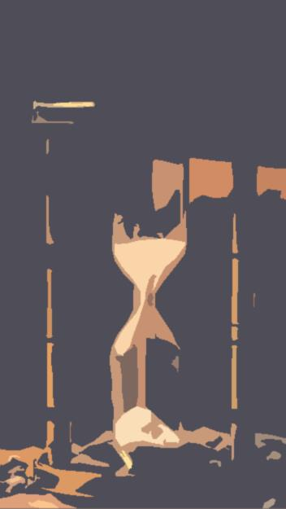**Peut-on discuter de la mort avec la personne malade, si oui quelle est votre approche ?**

* _ _ _ _ _ _ _ _ _ _ _ _ _ _ _ _ _ _ _ _ _ _ _ _ _ _ _ _ _ _ _ _ _ _ _ _ _ _ _ _ _
* _ _ _ _ _ _ _ _ _ _ _ _ _ _ _ _ _ _ _ _ _ _ _ _ _ _ _ _ _ _ _ _ _ _ _ _ _ _ _ _ _
* _ _ _ _ _ _ _ _ _ _ _ _ _ _ _ _ _ _ _ _ _ _ _ _ _ _ _ _ _ _ _ _ _ _ _ _ _ _ _ _ _
* _ _ _ _ _ _ _ _ _ _ _ _ _ _ _ _ _ _ _ _ _ _ _ _ _ _ _ _ _ _ _ _ _ _ _ _ _ _ _ _ _
* _ _ _ _ _ _ _ _ _ _ _ _ _ _ _ _ _ _ _ _ _ _ _ _ _ _ _ _ _ _ _ _ _ _ _ _ _ _ _ _ _
* _ _ _ _ _ _ _ _ _ _ _ _ _ _ _ _ _ _ _ _ _ _ _ _ _ _ _ _ _ _ _ _ _ _ _ _ _ _ _ _ _
* _ _ _ _ _ _ _ _ _ _ _ _ _ _ _ _ _ _ _ _ _ _ _ _ _ _ _ _ _ _ _ _ _ _ _ _ _ _ _ _ _
* _ _ _ _ _ _ _ _ _ _ _ _ _ _ _ _ _ _ _ _ _ _ _ _ _ _ _ _ _ _ _ _ _ _ _ _ _ _ _ _ _
* _ _ _ _ _ _ _ _ _ _ _ _ _ _ _ _ _ _ _ _ _ _ _ _ _ _ _ _ _ _ _ _ _ _ _ _ _ _ _ _ _
* _ _ _ _ _ _ _ _ _ _ _ _ _ _ _ _ _ _ _ _ _ _ _ _ _ _ _ _ _ _ _ _ _ _ _ _ _ _ _ _ _
* _ _ _ _ _ _ _ _ _ _ _ _ _ _ _ _ _ _ _ _ _ _ _ _ _ _ _ _ _ _ _ _ _ _ _ _ _ _ _ _ _
* _ _ _ _ _ _ _ _ _ _ _ _ _ _ _ _ _ _ _ _ _ _ _ _ _ _ _ _ _ _ _ _ _ _ _ _ _ _ _ _ _

